Bitrix Framework

Localization Gu

Adding a New Language to the System

Before you start translating the files, you have to add a target language into which you will translate the system forms and messages.

First, create profiles for the language cultural settings and the language itself.

Open the form Desktop > Settings > System settings > Language Parameters >
Regional Options and Culture to add language parameters.
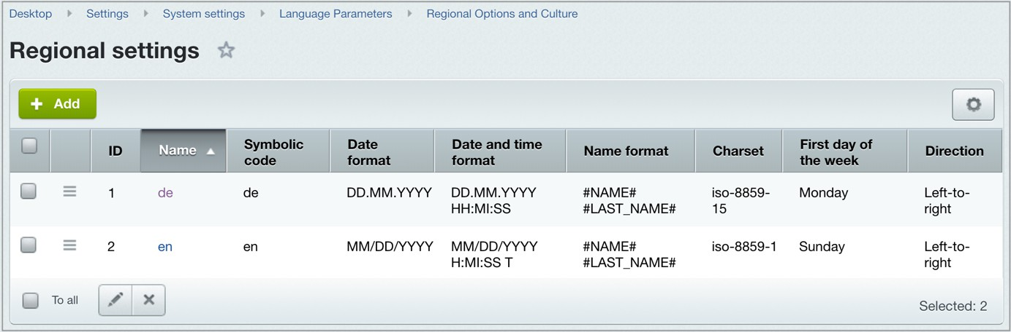

Click Add and enter the regional parameters of the new language.
Note: The fields marked in bold are mandatory.

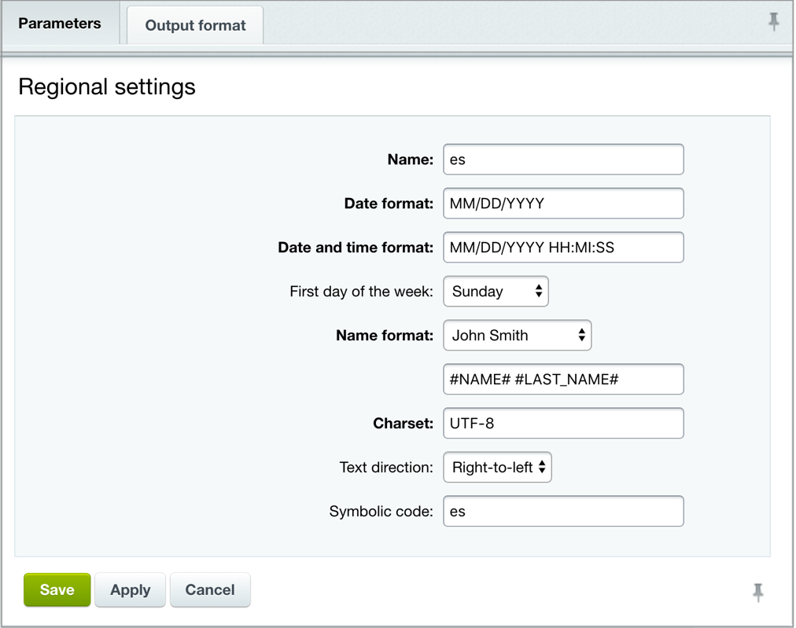

- Name – the name of the regional settings record.
- Date format – specifies format in which the date is represented in the new language.
- Date-time format – specifies format for the date and time combined.
- First day of the week – specifies the first day of the week.
- Name format – specifies format for the human names.
- Charset – specifies encoding in which the language messages are stored and displayed.
- Text direction – specifies direction in which text is rendered.
- Symbolic code – a two-character code for this set of regional parameters.

Go to the form Desktop > Settings > System settings > Language Parameters > Interface languages to add a new language profile:
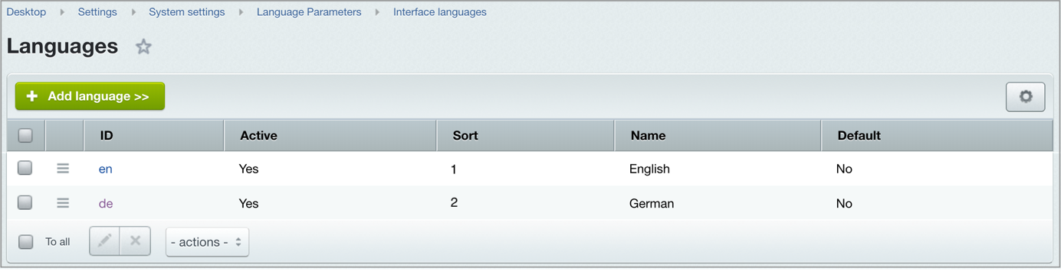

Click Add language and enter the language parameters and format.

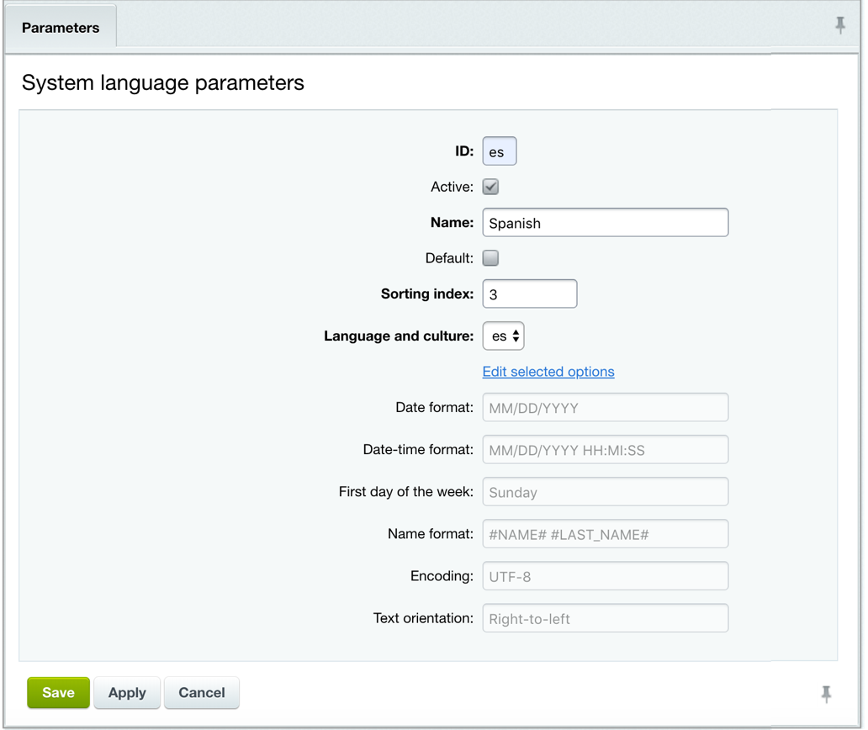
Here, the ID identifies the new language as per entry in the previous form.
Important! The system language identifier (ID) is used to locate and download the language files. The ID must have the same name as the language ID on the server.

For example, the server expects the ID de for the German language files. Therefore, you have to create a language that specifies the ID ‘de’ before downloading German language files.

Use the national language encoding as an interface language encoding or UTF- 8 if the entire project is in Unicode. You will find a complete list of language identifiers and encodings for different languages in the documentation.

  - Active – if checked, specifies that the language is shown in the language menu and can be selected for viewing the site.
  - Name – the name of the language as shown to a user.
  - Default – if checked, specifies that the language is used by default.
  - Sorting index – the position of the language in the list of available languages.
  - Language and culture – select here one of the previously created regional setting.

If so required, you can override the cultural settings by clicking the Edit selected options
link:

  - Date format: specifies the date format, e.g. DD.MM.YYYY
  - Date-time format: the date and time format, e.g. DD.MM.YYYY HH:MI:SS
  - First day of the week: a day that initiates the week In our example above it is Sunday.

  - Name format: specifies the human name format, for example: #NAME# #LAST_NAME#;
  - Encoding: UTF-8 or other encoding of your choice.
  - Text orientation: specifies the direction in which text is rendered.

Click Save. The new language is now added to the list of available system languages in the public area and the Control Panel toolbar.
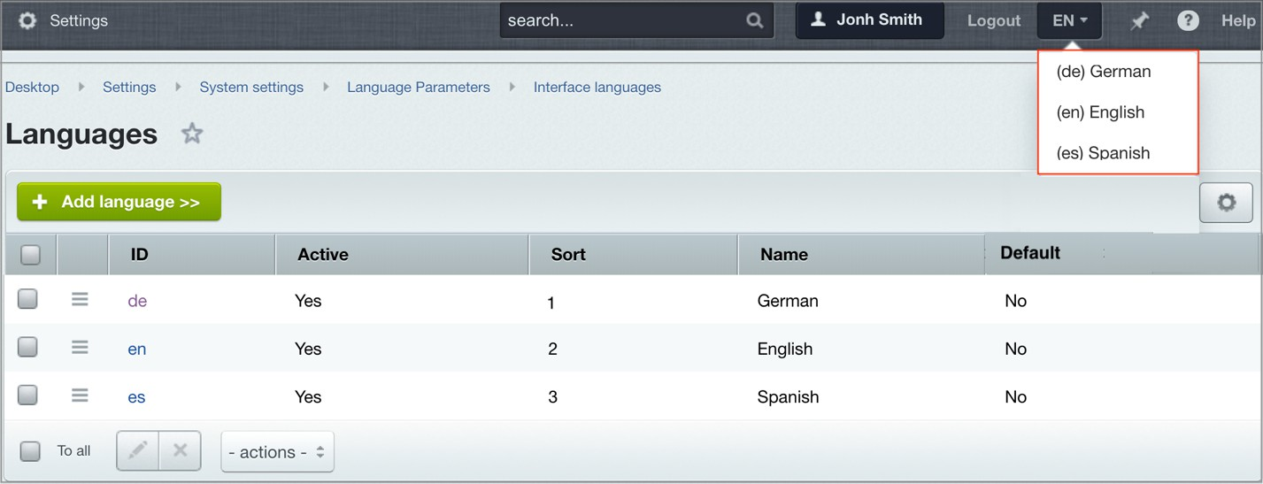

Importing and Exporting the Localization Archive

To import the localization, go to Desktop > Settings > Localization > Export And Import > Import Localization.

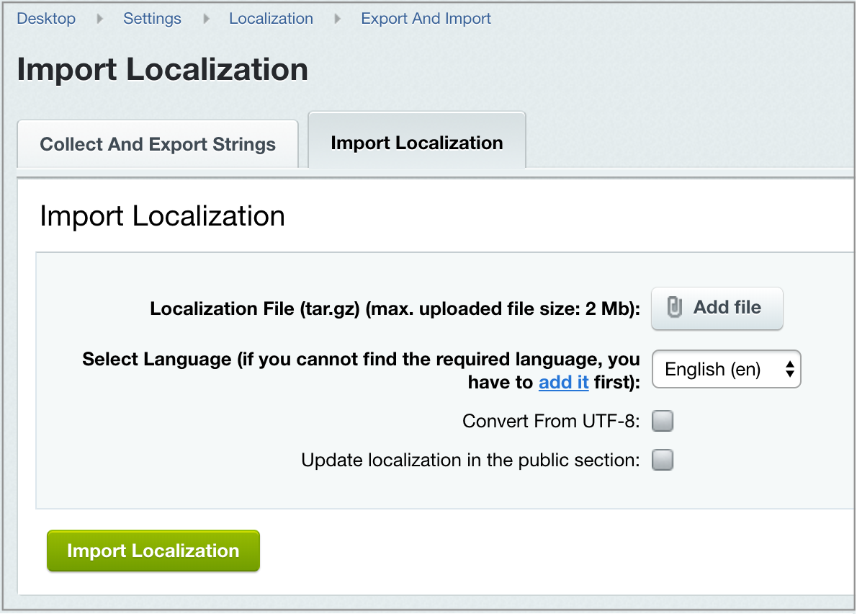

- Select Language – select here the language that the localization will be imported into.
- Convert From UTF-8 – select this option if the imported localization is in UTF- 8 encoding.
- Update Localization in the public section – if checked, the language messages in the public area of your project will be updated as well.

Click the Import Localization button to import the localization.

Downloading a Language Pack Using the Update System

Professional Bitrix developers and qualified Bitrix Partners are continuously updating the localizations for Bitrix24 Self-hosted version.

You can download a required language pack through the update system (Desktop > Marketplace > Platform Update).
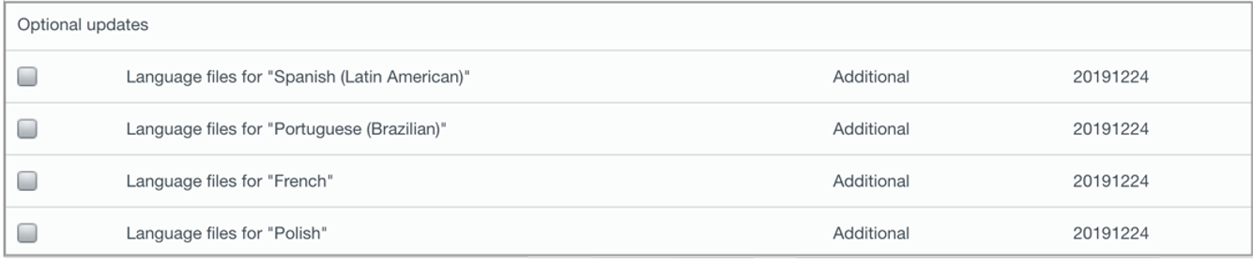

Adding a Language Selector in the Public Area
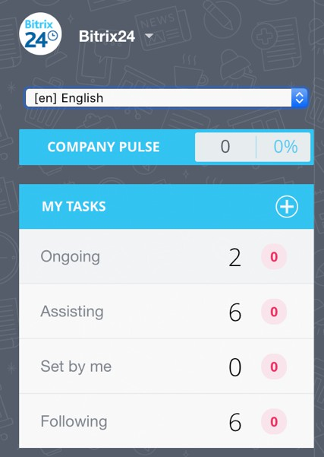
Giving your visitors an option to choose a site language is certainly a leap forward in user experience. Besides, it will only take you a few moments to implement.

- Add the following code to the /bitrix/php_interface/dbconn.php file:

<?
$arLang = array("en", "pl", "la");
if (isset($_GET["user_lang"]) && in_array($_GET["user_lang"], $arLang))
{
setcookie("USER_LANG", $_GET["user_lang"], time()+9999999, "/"); define("LANGUAGE_ID", $_GET["user_lang"]);
}
elseif (isset($_COOKIE["USER_LANG"]) && in_array($_COOKIE["USER_LANG"], $arLang))
{
define("LANGUAGE_ID", $_COOKIE["USER_LANG"]);
}
?>

- Add the following code to the <head> tag of the header file (/bitrix/templates/<template>/header.php) of the site template you use for your site:

<script>
function replaceQueryParam(param, newval, search)
{
var regex = new RegExp("([?;&])" + param + "[^&;]*[;&]?"); var query = search.replace(regex, "$1").replace(/&$/, '');
return (query.length > 2 ? query + "&" : "?") + (newval ? param + "=" + newval
: '');
}
function action_lang()
{
window.location = replaceQueryParam('user_lang', document.getElementsByName('Lang')[0].value, window.location.search);
}
</script>

- Finally, add the language selector to the template using this code:

<?echo CLanguage::SelectBox('Lang', LANGUAGE_ID,'','action_lang()');?>

You can add the selector to the header or footer of the template, depending on the design. More details can be found in the Template management topic.


The language selector does not translate content. All it does is change the UI messages to the selected language. However, the selector can change the menu language and message template. To do that, use another site template (in this case, a second template) to activate the menu that is translated into another language. This template also has to use language-dependent messages. A new set of TYPE and menu files are required to define menu items of the new language. Here’s how you will do it.

- Create a copy of the site template. To do that, simply copy the folder with the template to /bitrix/templates/. For the sake of an example, the site template will be in the folder /bitrix/templates/light/, and we make a copy in
/bitrix/templates/light_la/
- For convenience and to tell the two apart, we can change the description of the
light_la template in the file /bitrix/templates/light_la/description.php :
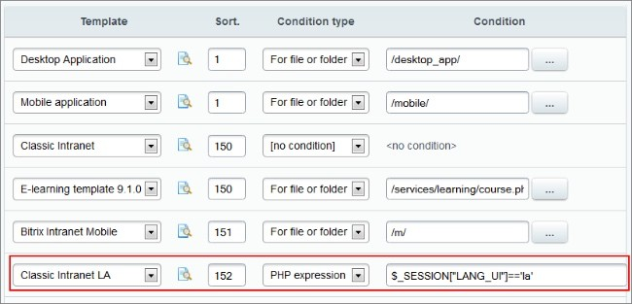

To make the selector work, we have to specify a condition to activate the template in the site settings (e.g. $_SESSION["LANG_UI"] == 'la').

Make sure you call the session_start() before adding items to the $_SESSION variable.

- For example, if you are using the top and left menu types in your site (the menu types are defined in the settings of the Site Explorer module), add a new menu type to describe the menu for the new language, like top_la and left_la:

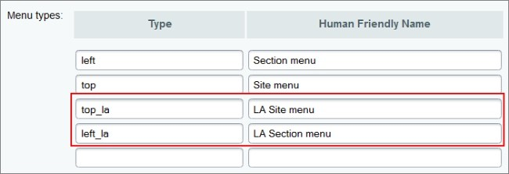

- In the light_la template, find the activation code for the menu components (in the files /bitrix/templates/light_la/header.php and
/bitrix/templates/light_la/footer.php) and change their menu type:

<?$APPLICATION->IncludeComponent("bitrix:menu", "horizontal_multilevel", array( "ROOT_MENU_TYPE" => "top_la",
"MENU_CACHE_TYPE" => "N", "MAX_LEVEL" => "3",
"CHILD_MENU_TYPE" => "left_la", "USE_EXT" => "Y",
"DELAY" => "N", "ALLOW_MULTI_SELECT" => "N"
),
false
);?>

- Finally, create a copy of these menu files in the site structure and translate them into the target language.
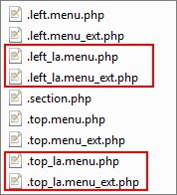
Note: When translating the menu in the Social Intranet template, in the
.left_la.menu_ext.php and .top_la.menu_ext.php files, change the template ID in the condition:

if (SITE_TEMPLATE_ID !== "bitrix24")

In our case, the condition will look like this:

If (SITE_TEMPLATE_ID !== "bitrix24_la")

Your template ID can be found in the list of templates here: Desktop > Settings > System settings > Websites > Site templates.

Showing Different Content for Different Languages
If you need to have different content for different languages, you have two options. The first option is create a ‘language mirror’ of the site. The second option is use the Bitrix multi-site feature.

If you're going with the first option, create a copy of the content in the second language. Static content (pages and sections) in this case has to be saved in different folders, for example:

En
...About
...Company
...News
De
...Überuns
...Mitarbeiter
...News

To have dynamic content rendered from a proper source folder, separate sources in each language need to be established. For example, to show a News page in the selected language, the component needs to point to an information block containing news items written in that language.

The language selector has to point to a folder with content in the other language.

When using the multi-site feature of the Bitrix platform, create a new site with its own content and objects (information blocks, polls, banners, training courses, etc.) in the target language.

